 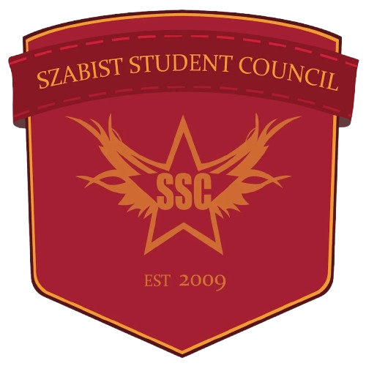 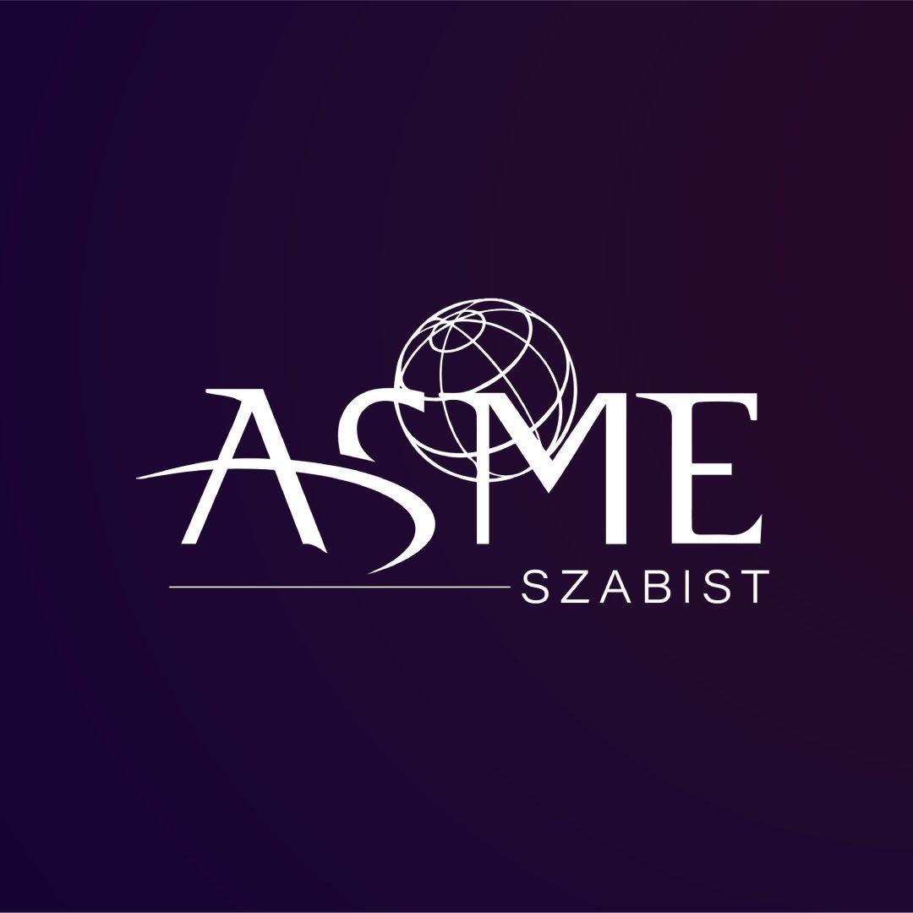

ASME SZABIST CHAPTER

## Cybersecurity Seminar – Event Write-Up

## Event Details

**Organizer:** ASME SZABIST Chapter  
**Event Title:** Cybersecurity Seminar – “Safeguarding the Digital Future”  
**Date:** Wednesday, 22 October 2025  
**Duration:** 2 Hours (Maximum)  
**Venue:** Seminar Hall 99 Campus, SZABIST University, Clifton, Karachi, Pakistan

## 1. Event Overview The ASME SZABIST Chapter held a two-hour seminar, “Cybersecurity: Safeguarding the Digital Future,” at SZABIST Clifton Campus to promote awareness of modern cyber threats and protective strategies.

## 2. Objectives

* To enhance students’ understanding of cybersecurity fundamentals and defense mechanisms.
* To provide exposure to real-world cyber threats, risks, and mitigation practices.
* To encourage student engagement and knowledge-sharing with industry professionals.

## 3. Event Structure

The seminar opened with welcome remarks and keynote sessions by cybersecurity experts on data protection, threat analysis, and network security, concluding with an interactive Q&A on practical challenges.

## 4. Event Flow (Tentative Schedule)

|  |  |
| --- | --- |
| **Time** | **Activity** |
| **11:30 AM – 12:00 PM** | New Registration & Welcome of Participants |
| **12:00 PM – 12:20 PM** | Opening Remarks and Introduction |
| **12:20 PM – 01:00 PM** | Speaker 1 Presentations and Discussions |
| **01:00 PM – 01:40 PM** | Speaker 2 Presentations and Discussions |
| **01:40 PM – 02:00 PM** | Interactive Q&A Session, Closing Remarks and Conclusion. |

## 5. Venue Preparation and Logistics

* Audio-visual setup with projector, microphones, and technical support.
* Proper seating and registration arrangements for attendees.
* On-site coordination and safety measures to ensure smooth execution.

## 7. Marketing and Promotion

The seminar was promoted via **ASME** official channels, **social media**, and **digital posters,** with society members boosting participation through **classroom outreach** and student networks.

## 12. Speaker Detail

* ***Mr. Muhammad Hasnain –*** Wing Head – Information Security at National Bank of Pakistan, with over 13 years of professional experience in cybersecurity governance, risk management, IT audit, and digital transformation security.
* ***Mr. Syed Mubbashir Mahmood –*** Unit Head Information Security, 10 years of experience in Vulnerability Assessment and Penetration Testing (VAPT), security assessments, and governance, risk, and compliance (GRC).

## 13. Conclusion

The **Cybersecurity Seminar** successfully achieved its objectives by providing students with valuable insights into digital safety, threat prevention, and information security. Through engaging sessions, expert presentations, and open discussion, the event strengthened students’ understanding of cybersecurity and its growing relevance in modern industries.

**Organizer:** ASME SZABIST Chapter

**Date:** Wednesday, 15 October 2025

**Venue:** Seminar Hall 99, SZABIST University, Clifton, Karachi

**Duration:** 2 Hours